Cubism in the Philippines

Cubism in Philippine art evolved from the background of a spirited struggle in the advent of modernism in the 1920s, a dispute often reduced into polarities. At one pole were the “conservatives,” led by Fernando Amorsolo and Guillermo Tolentino, who upheld a predominantly roseate imagination of reality; at the other were the “moderns” who advocated a depiction of a world that confronted violence. The latter indicated a turn in ideals and idealisations, stressing the activity of labour, the milieu of the city, and the anxiety of becoming a Filipino. Introduced by pioneers like Juan Arellano, Diosdado Lorenzo, Victorio Edades, Carlos Francisco, and Galo B. Ocampo, this modernist vocabulary was decidedly Post-Impressionist, though was inflected with the idiom of the art nouveau/art deco mural and the rhetoric of public ritual in which it was implicated. Francisco, whose magisterial works proved to be sprawling narratives of history retold through folk spectacle, most robustly embodied this temperament. It can be suggested that such curious mingling defined Philippine art’s attitude toward the Cubist vogue and the entire modern repertoire, which was ultimately enlivened by vivid popular realism, heroic posture, and a creative interaction with other disciplines like cinema, architecture, theater, and literature.

Cubism gained popularity in the Philippines under the rubric of Neo-Realism. A coterie of artists, some who belonged to the “13 Moderns,” called themselves Neo-Realists, but not as an allusion to Gustave Courbet’s realism nor to the approach in Italian filmmaking. We speculate that Neo-Realism was the apt modality through which Philippine modernists addressed the impasse between conservatism and modernism. The word realism deferred to the figuration of typical painting, while the prefix “neo” encouraged innovations within established genres. The art critic Leonidas Benesa has written that the Neo-Realists were “united under the aegis of Cubism.” Among the founding confreres, Manansala, Hernando R. Ocampo, and Cesar Legaspi pursued Cubism as a reference in their oeuvre, harnessing its pictorial potential to explore a range of concerns, from technique and composition to social protest and the sensation of speed. Cubism lent itself well to their visions. Manansala was versatile with it, modifying its design to concretize his sympathies with political commentary, Asian aesthetics, and the Dutch masters. Ocampo,was inventive with it, configuring motifs resembling flames or gems that when suffused with light and color would create stunning patterns. And Legaspi was lyrical with it, venturing into realms between radiance and shadow, disquiet and solitude. There was in all this an aspiration to the condition of sound and motion, translating into music, dance, frenzy, or reverie.

It can be assumed that Cubism in the long haul presented itself as the governing syntax through which a modernism veering away from the Post-Impressionist sensibility achieved a fluency in expression. Experiments with Fauvism, Surrealism, abstraction, and Expressionism were carried out in the laboratory of Cubism, yielding interesting formulations. For example, Galo B. Ocampo tired to sketch a surreal universe partly through Cubism. Ang Kiukok’s prolific expressionist corpus relied on it to sustain a hard-edged evocation of fortitude and indignation in hostile settings of screaming men, crucifixions, and junk and Arturo Luz’s acuity as a geometric abstractionist sought out Cubism to calculate a quality of light that is intractable and a color that is crystalline.

References and Further Reading

--- (2007) Cubism in Asia: Unbounded Dialogues, Tokyo: Japan Foundation.

Manansala, Rod. (1980) Paras-Perez, Manila: PLC Publications.

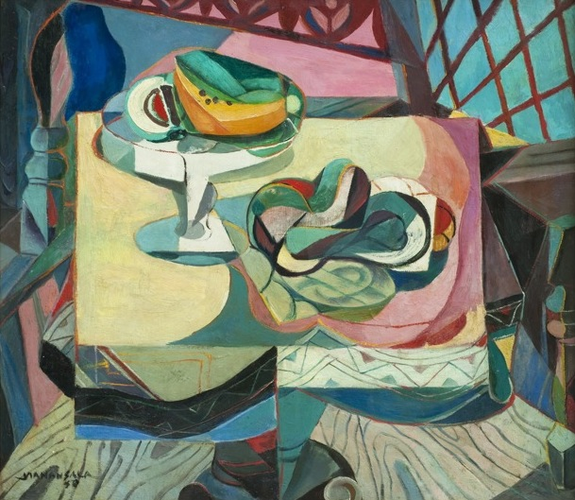

Vicente Manansala Mangga at Papaya, 1950, oil on masonite, 24 x 27 inches (Please contact Ms Hetty Que for permissions- mshskq@gmail.com)

